FREQUENTLY ASK QUESTIONS 2
MS-TEAMS PHONE APP
- Finding and adding the Phone App to Teams

Overview
When the Phone App is enabled for users in the service portal, it is automatically applied to users to add to their Teams client. This article describes how a user can add the Phone App to their Teams client and have it ready for use.

Adding the Phone App
The Phone App setup process automatically applies the Phone App to the user's Teams client. The user must select this from their Teams app gallery and pin it to their Teams app area:
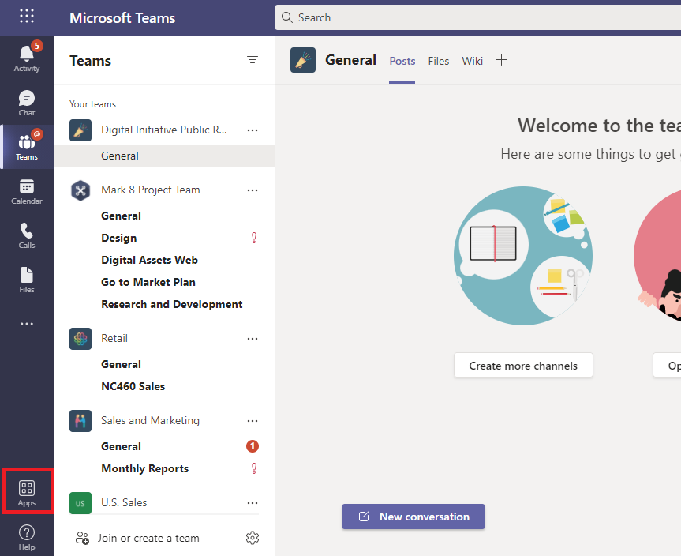
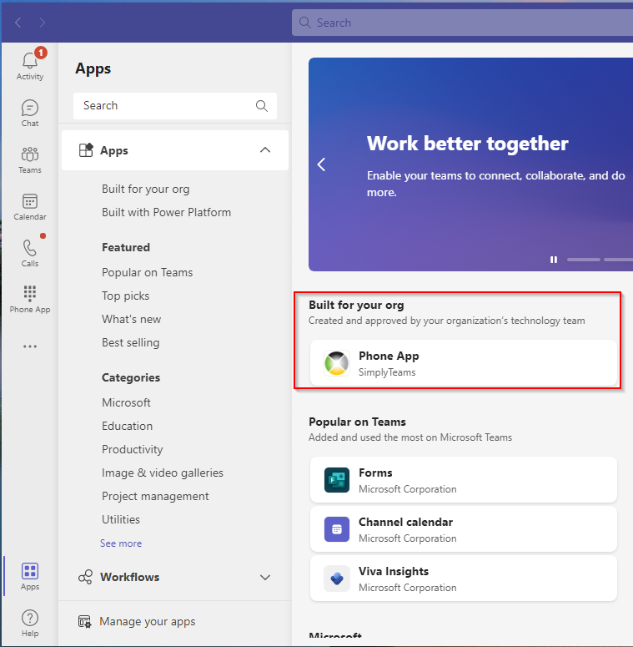

Select the Phone App:
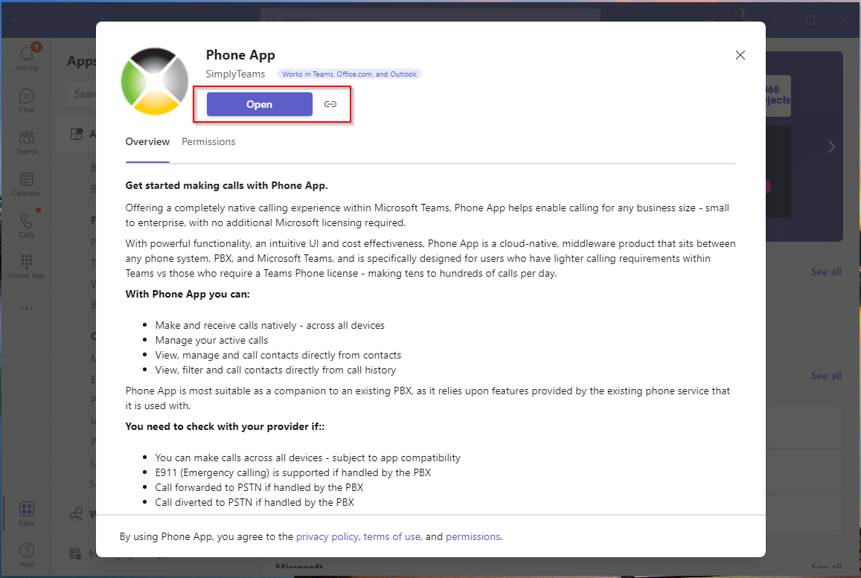

Selecting Open will add the App to the Teams client:
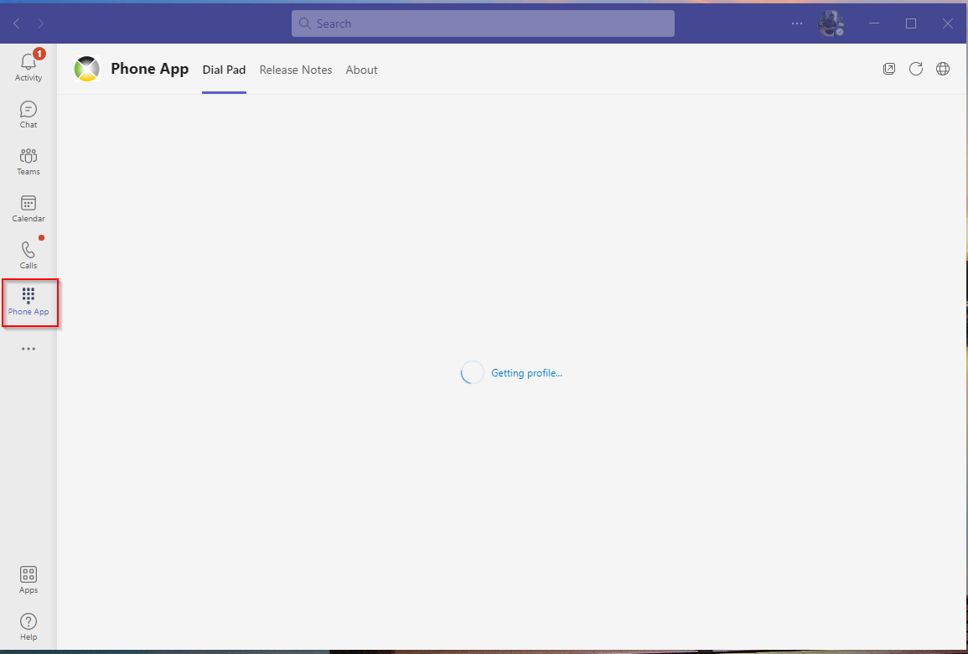

Users will see the Phone App icon added to their Teams bar:
Right-click on the App symbol to permanently pin the Phone App to the Teams bar.
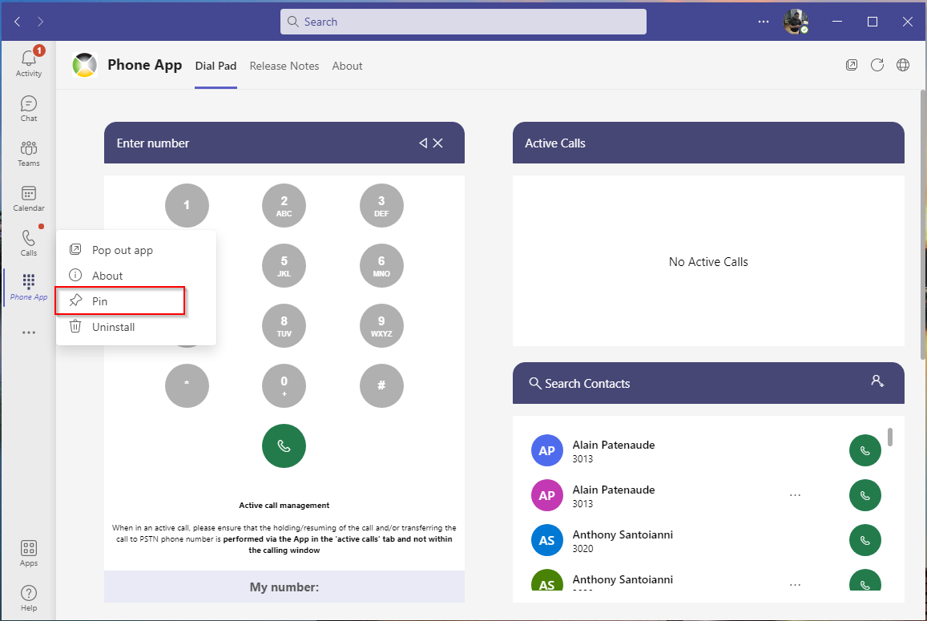

2 - Hold / Off Hold
Once in an active Phone App call you will have the option to put the call on hold via the Phone App main window.
The Phone App will mimic the same Hold scenario as Direct Routing sending an A=Inactive to the Teams Client and back to the PBX. This means that if your PBX currently supports it's own MOH with Direct Routing then it will work as expected.
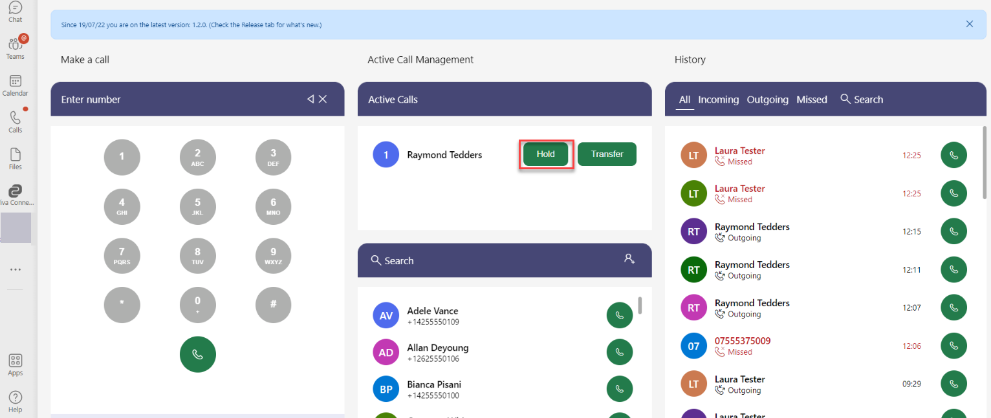

To Resume the call, you will notice the Active calls window changes to Resume allowing you to take the call off Hold.

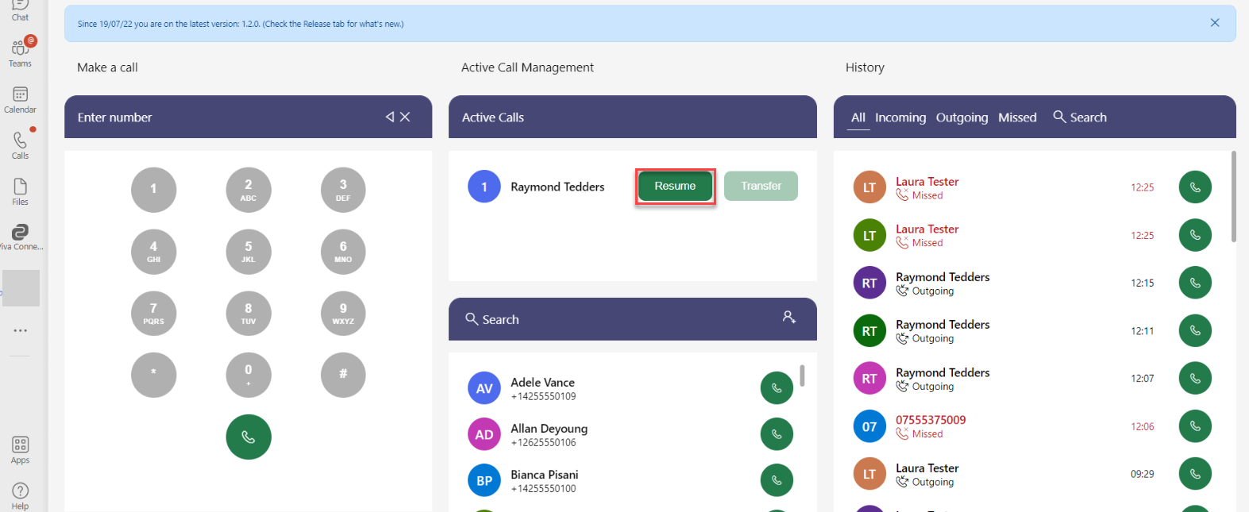

Manual Add/Edit/Remove Contacts
Phone App has the option to manually create your own contacts. By utilising Microsoft's Graph API's your contacts are stored within the users personal contact list within 365 and Outlook.
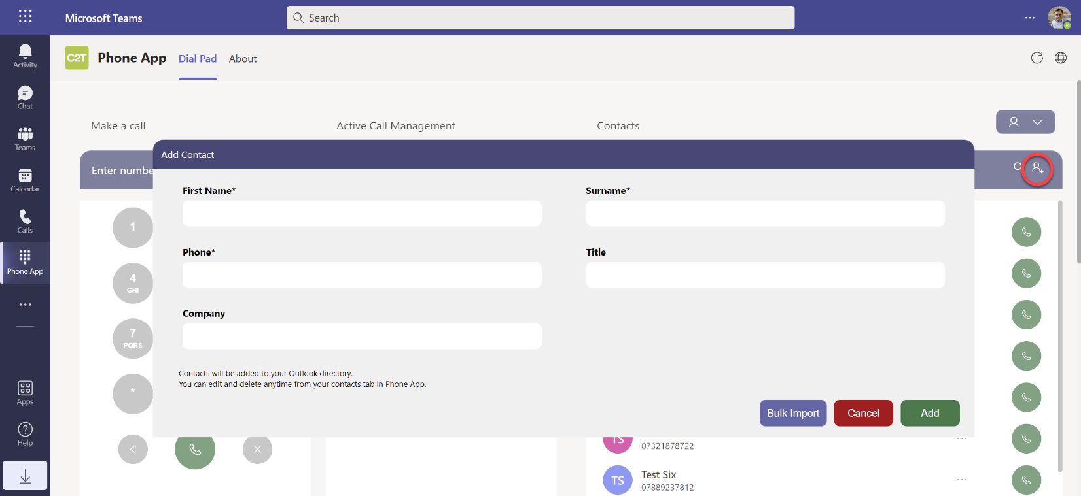
Bulk Upload is also available using a CSV file. (Template available at bottom of KB)
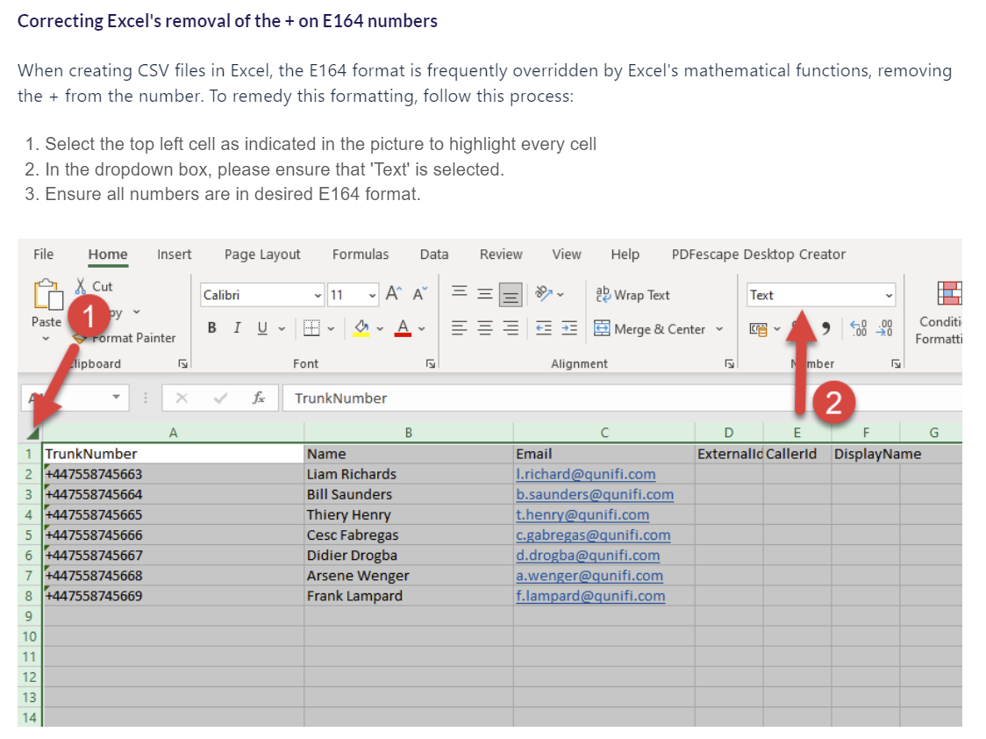
To Edit or Delete a contact see the three dots which provide the options per contact.
